Science & Math

Bioluminescence: a chemical reaction that lights up fireflies and jellyfish
By National Geographic, adapted by Newsela staff

10/02/2017
Word Count 857
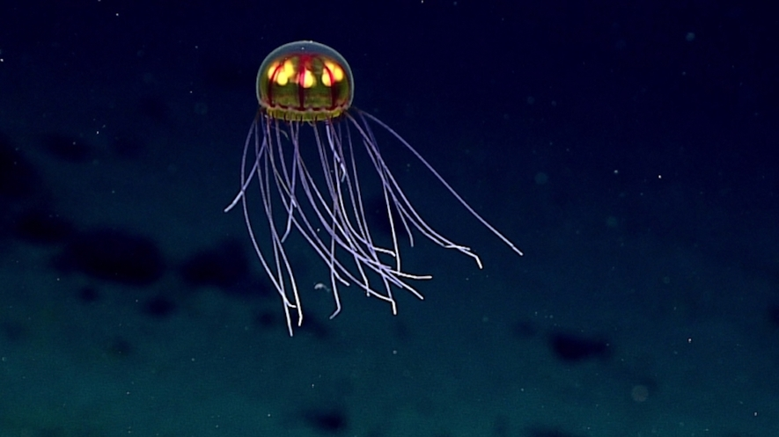This April 24, 2016, image made available by NOAA shows a bioluminescent jellyfish during a deepwater exploration of the Marianas Trench Marine National Monument area in the Pacific Ocean near Guam and Saipan. Photo from NOAA.gov/public domain

Bioluminescence is light produced by a chemical reaction within a living creature. Some bioluminescent fish, for example, have bodies that produce their own light, which can come in handy in the dark, ocean depths.
Most bioluminescent organisms are found in the ocean, including bioluminescent fish, bacteria and jellies. Other bioluminescent organisms, like fireflies and fungi, are found on land. An organism is any living being, like a plant or animal.
It should be noted that bioluminescence is not the same as fluorescence or phosphorescence. These happen when light is absorbed and then sent back out again. Fluorescence and phosphorescence are responsible for invisible ink and glow-in-the-dark stickers. Bioluminescent animals, on the other hand, produce light through a chemical reaction. In other words, bioluminescence happens when specific chemicals, or types of matter, mix with each other.

Chemistry
The chemical reaction that causes bioluminescence depends on two chemicals: luciferin and either luciferase or photoprotein. Luciferin is the chemical that actually produces light. When luciferase interacts with the luciferin and oxygen, it makes a new chemical and gives off light in the process.
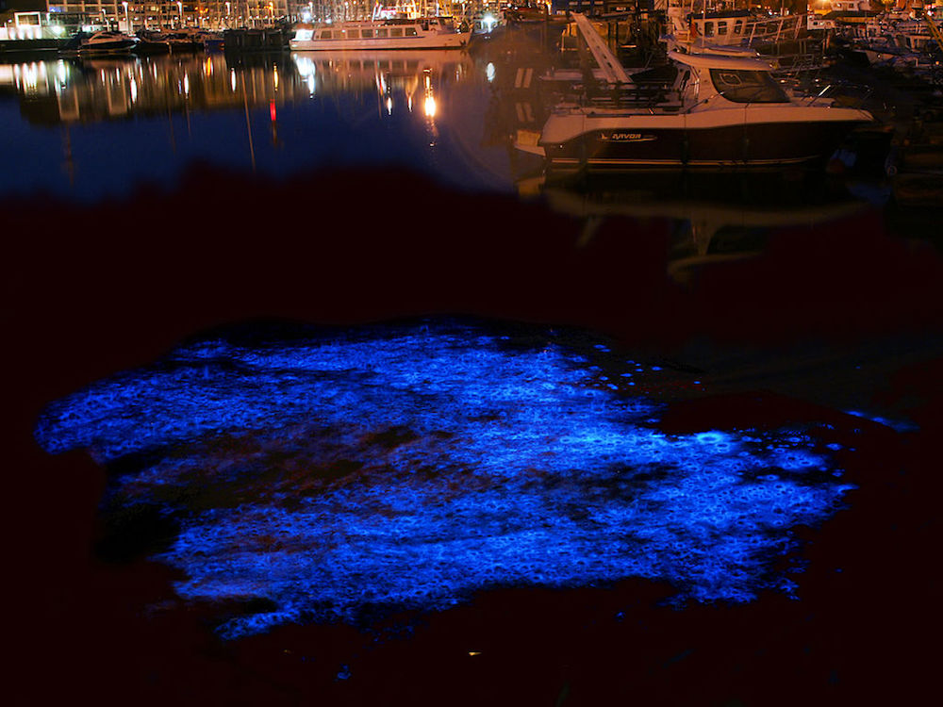 Tiny bioluminescent sea animals called dinoflagellates on a marina in Belgium.

Most bioluminescent reactions involve luciferin and luciferase, but they can also happen with a chemical called photoprotein. Photoproteins mix with luciferins, oxygen and calcium to make light.

Bioluminescent Light
The appearance of bioluminescent light varies based on where the organism lives. Most marine bioluminescence is blue-green, which is easier to see in the deep ocean. Most sea creatures cannot see yellow, red or violet colors.
Most bioluminescent organisms that live on land also give off blue-green light. Some creatures, like fireflies, glow with yellow light. Not many organisms can glow in more than one color, but one example is the so-called railroad worm. This animal can make its head glow red while its body glows green.
Some organisms shine light constantly. Most organisms, however, flash their light for less than a second to about 10 seconds. These flashes can happen in specific spots, like the dots on a squid. Other flashes can shine from the organism's entire body.

Adaptations
Bioluminescence can be used to hunt prey, defend against predators, find mates, and more. Some animals, including many kinds of squid, light up in order to confuse attackers. A flash of light can create enough of a pause to let the prey escape.
Bioluminescence can also be used for counterillumination. Many predators, such as sharks, hunt from below, looking up to find their prey's shadows. Counterillumination is a type of camouflage used by marine animals like the hatchetfish. Hatchetfish can shine light downward and match the sunlight coming from above. By changing their bioluminescence, they hide their shadows and become invisible to predators.
Some animals take even more extreme measures. Brittle stars can detach glowing body parts to distract predators. The predator follows the glowing arm of the brittle star, while the rest of the animal crawls away in the dark.

Offensive Adaptations
Bioluminescence may also be used to search for and attract prey. The most famous predator to use bioluminescence may be the anglerfish. The anglerfish has a huge head, sharp teeth and a long, thin, fleshy growth on top of its head, called a filament. On the end of the filament is a ball, or esca, that the anglerfish can light up. Smaller fish, curious about the spot of light, swim in for a closer look. By the time they see the enormous, dark jaws of the anglerfish behind the bright esca, it may be too late.
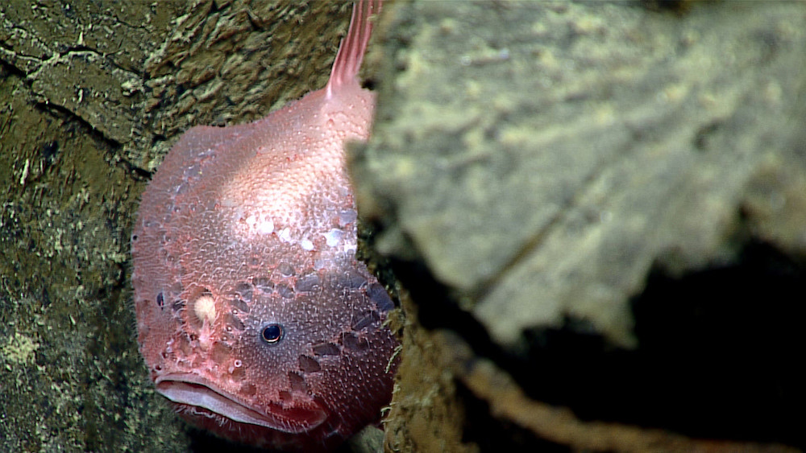
A deep-sea anglerfish. This creature can light up a filament between its eyes.

Other fish, such as a type of dragonfish called loosejaws, use bioluminescence to search for prey. Loosejaws have adapted to shine a red light. Most fish can only see blue light, so loosejaws have an enormous advantage when they light up a surrounding area. They can see their prey, but their prey can't see them.

Attraction
Adult fireflies, also called lightning bugs, are bioluminescent. They light up to attract mates. Although both male and female fireflies can produce light, most flashing fireflies in North America are male. The pattern of their flashes tells nearby females what species of firefly they are and that they're interested in mating.

Other Bioluminescence
Not all bioluminescent organisms are predators or prey. Algae, for example, are plants that float in the water, and bioluminescent algae can sometimes cause parts of the ocean to glow.
"Milky seas" are waters that glow thanks to bioluminescent bacteria on the surface. Bacteria are too small to see, but their light can be bright and large enough to be visible from space.

Bioluminescence And People
Scientists are studying bioluminescence to understand how people can use it to make life easier and safer. Bioluminescent trees, for example, could help light city streets and highways. Bioluminescent crops and other plants could glow when they needed water or other nutrients, or when they were ready to be harvested.
These are just a few examples of how this amazing natural process might be adapted for human use.

