8th Grade Science EOG Review Booklet
Use it. Study it. Pass the EOG!
Name________________________________________________
Block_______________

Classification of Matter

Everything that has mass and volume is made of matter.

Atoms are the building blocks of matter. They cannot be broken down into smaller pieces using chemical reactions or physical change. Various groups of atoms compose all known matter. Matter can be classified into two major categories: pure substances and mixtures.
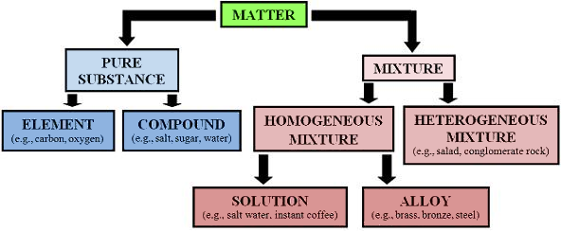

Pure Substances

A pure substance is a type of homogeneous matter that is made up of only one kind of material. All the particles (i.e., atoms or molecules) in a pure substance are exactly the same, and the same properties are exhibited throughout the substance. There are two main types of pure substances: elements and compounds.
- Elements—Elements are the simplest pure substance, because they are made up of only one type of atom. For example, the element carbon is only made up of carbon atoms, and the element zinc is only made up of zinc atoms. The simplest unit of an element that still has the properties of that element is the atom. Today, there are over 100 known elements. These elements are represented by chemical symbols (e.g., C represents carbon and Zn represents zinc) and are listed in order of their atomic numbers on the periodic table.
- Compounds—Compounds are pure substances that are made up of more than one type of element, chemically combined in a fixed ratio. Although the properties of a compound differ from the properties of the elements that compose it, the molecules of a compound exhibit the same properties as one another. Also, since the elements within a compound are chemically combined, they can only be separated by chemical changes, such as the change caused by electrolysis.
Compounds have a definite chemical composition that can be identified using a chemical formula. Water (H₂O), salt (sodium chloride, NaCl), and sugar (glucose, C₆H₁₂O₆) are all examples of compounds.
Mixtures
Mixtures are made up of two or more substances that are not chemically combined. Because they are not chemically combined, the substances retain their own individual properties of matter, even though they are mixed together. Furthermore, mixtures can be separated by physical means, such as filtration or distillation.
- Homogeneous Mixtures—A homogeneous mixture is uniform. That is, it has the same properties throughout. Solutions and alloys are two types of homogeneous mixtures. In a solution, one substance is dissolved into another substance (e.g., salt water, instant coffee). The substance being dissolved is called the solute, and the substance doing the dissolving is called the solvent. In solutions and alloys, the solute is evenly distributed in the solvent. In aqueous solutions, water is the solvent. A solution of a solid in a liquid can generally be separated through the process of vaporization. An alloy is a solid solution in which one metal is dissolved into another (e.g., the alloy brass is made of copper and zinc).
- Heterogeneous Mixtures—A heterogeneous mixture does not have the same properties throughout. In fact, the substances in a mixture often keep their own separate identities and individual properties. For example, a tossed salad is a heterogeneous mixture, and its properties are not the same throughout. Instead, each part of the salad (e.g., lettuce, tomato, croutons, etc.) keeps its own individual identity and properties.
Some heterogeneous mixtures are suspensions—fluids which contain insoluble solid particles that eventually settle out. A mixture of fine sand and water is a suspension. The pictures below illustrate how, after being mixed with water, sand particles settle to the bottom of the container.
Some mixtures can be difficult to classify. For example, colloids may be classified as a heterogeneous or a homogeneous mixture, depending on the context. In a colloid, solid particles are dispersed in a liquid. While the particles are not dissolved, they may be dispersed well enough that they will not settle out over time as would a suspension. Milk is an example of a colloid. Unlike the components of solutions, the components of a colloid can be separated from one another using a filter if the pores of the filter are sufficiently small.
Mixtures can occur between all phases of matter.

The Periodic Table

The Periodic Table is a chart displaying information about the elements. Elements are arranged in the
table in a specific pattern that helps to predict their properties and to show their similarities and differences.

The periodic table was developed by Dmitri Mendeleev in 1869. It provides a powerful tool for studying the elements and how they combine. There are over 100 known elements, so it is necessary to use a systematic method to organize them. The periodic table indicates each element's atomic symbol, atomic number, and average atomic mass (also called atomic weight).
The placement of an element on the periodic table gives clues about the element's chemical and physical properties, including its melting point, density, hardness, and thermal and electrical conductivities.

Periods

The periodic table is so named because it is organized into "periods." A period is defined as an interval required for a cycle to repeat itself. In the periodic table, the periods are the horizontal rows that extend from left to right. These periods consist of as few as two elements and as many as thirty-two elements. Both the atomic number and the atomic mass of the elements increase moving across the table from left to right and down the table from top to bottom.

Groups and Families

The division of elements into vertical groups by column creates families of elements. Elements in the same group all have similar chemical properties. For example, lithium (Li), which is in group 1, can easily combine with chlorine (Cl), which is in group 17, and form lithium chloride (LiCl). Since sodium (Na) is also in group 1, it has similar chemical properties to lithium, and it can also combine easily with chlorine and form sodium chloride (NaCl).
Some individual groups (or families) in the periodic table also have special names. The properties of these groups are described below:
- Group 1: Alkali metals– All of the elements in group 1 of the periodic table (except hydrogen) are alkali metals. They are soft metallic solids with low melting points and they are the most reactive metals.
- Group 2: Alkaline earth metals– All of the elements in group 2 of the periodic table are alkaline earth metals. They are hard metallic solids and have higher melting points than alkali metals. Though they are also highly reactive, they are less reactive than alkali metals.
- Group 17: Halogens– All of the elements in group 17 are halogens. They have low boiling points and low melting points.
- Group 18: Noble gases– All of the elements in group 18 are noble gases. They tend to be stable and unreactive. In general, noble gases do not react or combine with any element.
- Groups 3-12: Transition metals– Elements located in groups 3-12 on the periodic table are known as transition elements. These elements tend to be hard metallic solids, and have high heat and electrical conductivities.

Metals, Nonmetals & Metalloids
The elements in the periodic table can be subdivided into metals, nonmetals, and metalloids. The stair step line that begins between boron, B, and aluminum, Al, and moves down and right to polonium, Po, and astatine, At, is the dividing line between metals and nonmetals.
This division is shown by the different colors in the periodic table below.
- Metals are the elements to the left of the stair step. Metals are typically dense solids with a shiny luster. They tend to form positive ions and are capable of conducting electricity. Metals most often form ionic bonds with nonmetals and metallic bonds with metals.
- Nonmetals are elements to the right of the stair step plus hydrogen. They tend to have low densities, a dull luster, low melting points, and do not conduct electricity. They are often brittle. Nonmetals tend to form ionic bonds with metals and covalent bonds with other nonmetals.
- Metalloids are the elements along the stair step that have some of the properties of both metals and nonmetals. The metalloid elements are B, Si, Ge, As, Sb, and Te. Some of these elements, such as Si and Ge, are semiconductors. Exceptions to the stair step rule include Al, Po, and At, though, Po and At, have also been classified as metalloids by some scientists.

The periodic table is very carefully organized. A wealth of information can be found in the periodic table if one understands how to use it.

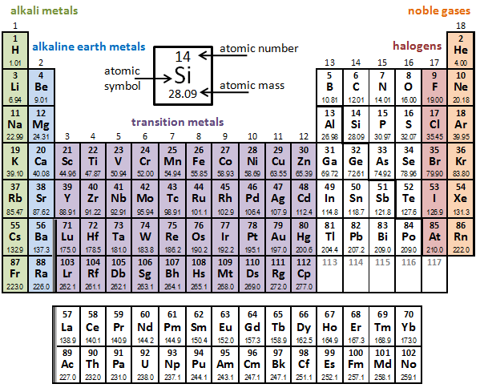

Chemical and Physical Properties

Each substance has its own unique combination of physical and chemical properties,
and substances can be identified based on these properties.

PHYSICAL PROPERTIES are characteristics of an element or compound that can be observed without changing the identity of the substance. They are the properties that the substance already has. Color, density, mass, and solubility are all physical properties. During a physical change, substances are not altered chemically. They simply change from one state of matter to another, or they separate or combine without breaking or making bonds. Changes of state are physical changes. Making and separating mixtures are also physical changes. Mixtures can be separated using the differences in physical properties of each substance.

Mass is the amount of matter in an object. Mass is different from weight.

Weight is a force due to the pull of gravity on an object. The mass of an object stays constant in all situations. Weight, however, is influenced by the strength of the gravitational pull.

Volume is the amount of space occupied by a substance; size.

Density is how much mass a material has per unit of volume. Denser materials have more matter in a given space than less dense materials. Density is found by dividing the mass of an object by its volume.

Appearance is how something looks. The property of appearance might include color, luster, shape, and the degree to which an object is transparent or opaque.

Odor is the smell that a substance gives off. For example, vinegar has a pungent odor.

Texture is how a substance feels to the touch. For example, sand has a grainy texture, while talc has a soft, fine texture.

The boiling point is the temperature at which a liquid changes to a gas. For water, it is 100 °C or 212 °F.

The melting/freezing point is the temperature at which a liquid changes from a solid to a liquid. For water, it is 0 °C or 32 °F.

Solubility refers to the ability of a substance to dissolve in a solvent such as water or the amount of a substance that can dissolve in a certain amount of water. The solubility of salt is about 36 grams per 100 mL of water.

Conductivity refers to the ability of a substance to transmit energy. Usually this refers to its ability to conduct electricity, but it may also refer to its ability to conduct heat. Metals and solutions that contain ions, such as HCl in water, can usually conduct electricity.

Magnetism refers to the ability of a substance to respond to a magnetic field. Metals such as iron, nickel, and cobalt are magnetic because they can be attracted by magnetic fields.

CHEMICAL PROPERTIES are the characteristic ways in which an element or compound chemically behaves. They describe how substances react under certain conditions and with other substances. Chemical properties primarily depend on the types of atoms and bonds that are in a substance. During a chemical change, a chemical reaction takes place. Atoms are rearranged by making and/or breaking bonds to form new substances with different properties. Chemical properties and changes can be used to identify a substance, but these methods always change the substance into a new compound.

Reactivity describes whether a substance reacts easily with other substances. For example, most metals will react with acids.

An unreactive substance does not react easily with most other substances. The noble gases are the least reactive elements, and water is an example of an unreactive compound.

The ability to react with acids or bases describes whether or not a substance reacts chemically with an acid or a base.

Flammability describes the ability of a substance to ignite or burn.
Combustibility describes the ability of a substance to react rapidly with oxygen and release energy in the form of heat and/or light.

The ability to oxidize or the ability to rust refers to the tendency of some metals to rust or corrode by reacting with oxygen in the air.

Physical & Chemical Changes

Matter can undergo physical and chemical changes. When a physical change occurs, a substance changes without altering its composition. When a chemical change occurs, a substance has chemically reacted to form one or more different substances.

PHYSICAL CHANGES
When a physical change occurs, a substance changes its appearance but not its identity or chemical composition. For example, paper appears different after it has been shredded. However, the substance is still paper.

Some examples of physical changes include:
- liquid freezing into solid
- shredding a piece of paper
- pounding a metal, such as aluminum, into thin sheets
- breaking glass
- filtering a solid from a liquid
- a solid expanding as it is heated
A change in state is a physical change. When water is boiled it becomes vapor. The water changes from a liquid to a gas. However, the water is still water, so it is a physical change. When solid gold is melted, it changes state as it becomes a liquid. However, the gold has not changed its identity, (it is still gold), so this is also a physical change. Changes in state are physical changes. Water can change from a solid to a liquid, but it is still water.

A CHEMICAL CHANGE occurs when a substance changes its identity because its particles have been rearranged. The new substance that is formed has its own new properties.
For example, when zinc metal is placed in a hydrochloric acid solution, it reacts with the acid. The zinc atoms combine with chlorine atoms from the acid, and it becomes zinc chloride and hydrogen gas. All chemical changes involve chemical reactions. Chemical reactions can be written in the form of a chemical equation. The reaction of zinc (Zn) with hydrochloric acid (HCl) is represented by the following chemical equation: Zn + 2HCl → ZnCl₂ + H₂. The properties of a product created during a chemical reaction are not necessarily the same as those of any of the reactants that make them up. In the reaction above, zinc is a solid that does not dissolve in water. The zinc chloride produced during the reaction, however, does dissolve in water.

The following are examples of important chemical changes.
- silver metal reacting with sulfur to form sulfur sulfide, or tarnish
- burning hydrogen gas in air
- heating a compound until it breaks down or decomposes
- the oxidation of metals in air, or rusting
- the reaction of an acid and a base
In each of these cases a chemical reaction has taken place, and the way that the atoms are arranged in the substance has changed. The same types of atoms are present, but they have separated or combined in new ways to form different substances with different properties.

Evidence of a Chemical Reaction
The following are examples of the most common signs that a chemical reaction has occurred.
- Change in Temperature: Reactions may either produce heat or absorb heat. If two room temperature liquids are mixed and the mixture gets hotter or colder, then a chemical change is probably taking place. Putting a substance in the refrigerator is not a chemical change.
- Color Change: If two substances are mixed and their color changes, then a chemical reaction may be taking place. This type of color change does not include color blending. Mixing red and blue paint to make purple is a physical change, not a chemical one.
- Making a New Solid or Gas: Another sign of a chemical change is the production of a solid precipitate or the development of a gas. A precipitate is a solid that forms from mixing two liquids. The production of a gas can be seen as bubbles. Freezing or boiling a substance, however, are physical changes.
In every case, a chemical change has occurred if the identity (molecular structure) of a substance has changed. If there has been a change in appearance, but not in identity, then only physical changes have occurred.

Mixture Separation
A mixture is made up of two or more substances that are not chemically combined.
Mixtures can be separated by physical means, so mixture separation is a physical change.
Differences in physical properties such as density, particle size, molecular polarity, solubility, and boiling and freezing points permit physical separation of the components in a mixture. Some of the techniques that can be used to separate mixtures are discussed below.

Filtration If a mixture is composed of a liquid and an insoluble solid, the mixture can be separated by filtration. During filtration, the mixture is poured through a filter. The solid is trapped by the filter, but the liquid goes through the tiny pores in the filter and can be collected in a container beneath.

Evaporation If a mixture contains a soluble solid dissolved in a liquid, the two mixture components can be separated by evaporating the liquid off. As the solvent evaporates, the solid solute remains behind as a residue. Heat may or may not be used to accelerate evaporation. If large, pure crystals are desired, evaporation should be allowed to take place over as long a period as possible. However, if crystal size is irrelevant and purity is not a concern, the liquid can be boiled off rapidly. In the image below, an aqueous solution of sodium chloride (salt) was boiled until only a solid salt residue remained in the heating vessel.

Sifting Sifting, also called screening or sieving, is a method of filtering solids from one another based on particle size. For example, sifting could be used to remove small pebbles and shells from sand. A sieve or sifter like the one shown above is often used in kitchens to remove lumps from flour.

Conservation of Matter
When a substance goes through a chemical or physical change, the total mass of the substance or substances stays the same.
This is because matter can neither be created nor destroyed by physical or chemical changes. It can only change forms.
According to the law of conservation of matter, matter is neither created nor destroyed. The mass of a substance will remain constant whether it is whole, separated into pieces, or in a different state. If a substance undergoes a chemical change, the masses of the products will equal the masses of the original reactants.

Matter Conservation in Physical Changes

If 50 grams of pure ice melts into liquid water, the form of the water changes into a liquid, but the amount of matter is the same. The liquid water will have a mass of 50 grams. If the 50 grams of liquid were allowed to boil in a pan until there was nothing left in the pan, the mass of the steam created would also be 50 grams.

Matter Conservation in Chemical Reactions

During a chemical change, atoms are rearranged to produce one or more new substances. These kinds of changes can also be called chemical reactions. Mass and energy are conserved in these reactions. For example, if charcoal is burned in air, the charcoal reacts with oxygen to form new chemical compounds. If the masses of all the products of the reaction (ashes, soot, gases) are added together, however, this mass will be equal to the original mass of the charcoal plus the oxygen it reacts with. Mass is not created or lost, it just changes into different substances.

Chemical equations can demonstrate how matter is conserved in a reaction because the number of reactant atoms always equals the number of product atoms. Chemical equations have the following general format: reactants products
Reactants are the starting substances in the reaction. Products are the substances that are produced following the reaction. The equation below shows the reaction of hydrogen gas and oxygen gas to form water. 2H₂ + O₂ 2H₂O
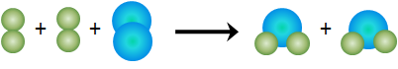
In the above reaction, two molecules of hydrogen gas react with one molecule of oxygen gas to produce two molecules of water. In this case, the reactants are hydrogen gas and oxygen gas, and the product is water. The arrow always points toward the products. The coefficients, or the numbers in front of each substance, indicate how many molecules of that substance are present. The subscripts, or the small numbers that follow particular elements, indicate how many atoms of that element are present in a substance. So, in the above example, the two in front of the H₂ indicates that there are two molecules of hydrogen gas. The two that follows the H indicates that there are two atoms of hydrogen in each hydrogen molecule. The picture below shows the same reaction using models of the atoms in the reaction.
Although the atoms rearrange, there are four hydrogen atoms and two oxygen atoms on each side of the equation. This shows that atoms were not created or destroyed, only rearranged. That is, matter is conserved in the chemical reaction.

Energy Resources

NONRENEWABLE Energy Sources

Any resource that is used at a faster rate than it can be replaced is called a nonrenewable resource. Most of the energy that is currently used comes from non-renewable sources. Fossil fuels and nuclear energy are both considered to be nonrenewable resources, and if they continue to be used at the current rate, these resources will eventually run out.

Fossil Fuels- The most common method for obtaining energy is through the burning of fossil fuels, such as coal, oil, and natural gas. These fuels can be converted to other forms of energy in many ways, including the production of electricity through coal-burning power plants. Fossil fuels are abundant and cheap, and coal-burning power plants are currently the most effective way for generating widespread electricity where and when it is needed. However, coal-fired power plants cause large amounts of pollution and can affect the Earth's natural greenhouse effect. Power plants burn coal in order to produce electricity. While coal is plentiful and cheap, it produces a significant amount of air pollution. Measures are being taken to reduce the amount of pollution released by coal burning, but it is impossible to completely eliminate it.

Nuclear Energy- Nuclear energy is produced by splitting atoms of certain elements, such as uranium. The energy released by this process is then used to heat water to produce steam. Nuclear power plants generate electricity by capturing the energy of the rising steam, which turns the turbines that run generators. The main environmental drawback to using nuclear energy is that it produces radioactive waste, which is harmful to organisms and may remain harmful for thousands of years. Also, nuclear energy is a nonrenewable energy resource because it relies on materials that are limited in supply. However, many scientists believe nuclear energy could remain viable for more than 1,000 years at current usage rates.

RENEWABLE Energy Sources

Some resources are replaced more quickly, or about as quickly as we can use them. These resources are called renewable. One drawback to the usage of many renewable energy sources is that technology and infrastructure for efficiently storing and transferring energy generated from these sources is not yet in place.

Hydroelectric Energy- Dams have been constructed to control rivers all over the world. The held-back water contains potential energy, which is converted to kinetic energy as it is then released through tunnels. Hydroelectric dams were designed to convert the kinetic energy of falling water into electrical energy. Hydroelectric energy is much cleaner than fossil fuels, but the construction of dams is extremely disruptive to natural ecosystems, especially where it prevents fish and other aquatic animals from moving up or down a river.

Solar Energy- Solar power has far fewer environmental consequences than fossil fuels. The negative effects of using solar energy are minor and are primarily related to the manufacturing and disposing of the solar panels which convert solar energy into electrical energy. Cost is the main reason that the solar technology is not more widespread. Solar energy is very expensive to harness in useful quantities. One other negative effect of using solar-generated electricity is that the large collections of panels needed to create a solar power station can significantly impact local ecosystems. Solar energy is also not as reliable as energy derived from fossil fuels, because weather is inconsistent, and the amount of sunlight available on any given day may not be sufficient to produce the needed amount of energy from solar panels. In addition, some latitudes and geographic locations may be more suitable for solar power than others. But as the technology continues to improve, solar energy costs decrease, and more solar panels are being implemented. Solar energy can be harnessed using solar panels. While this process results in far less pollution or waste than burning fossil fuels, it is currently very expensive and therefore not yet used widely across the world.

Wind Energy- As with solar energy, wind energy has very few negative environmental consequences, and these are mostly related to the manufacture and disposal of wind turbines. Wind turbines also pose hazards for birds and bats, and some communities may not embrace the establishment of wind farms because some people find the appearance of the large turbines off-putting. Unlike the technologies related to solar energy, wind technologies are relatively inexpensive. In terms of electricity prices, wind energy is able to compete with fossil-fuel generated electricity, but there are limitations to wind as well. Wind turbines are used to convert blowing wind energy into electricity. This process offers a much cleaner alternative to burning fossil fuels, but not every location is suitable for wind power

Biomass Energy- Biomass energy is perhaps the oldest form of energy used by humans. Biomass is simply plant or animal material, such as wood, manure, grass, and hay. The difference between biomass and fossil fuels is that biomass is from living or recently living organisms, while fossil fuels come from long-dead organisms. Consequently, biomass is considered renewable as long as it is used at the same rate (or slower) than it is replaced. Biomass is traditionally burned for heating and cooking, but it can also be used to generate electricity. Burning biomass releases many pollutants into the air.

Food, Cellular Energy & Life Processes

All living organisms on Earth are made up of one or more microscopic structures called cells.
All organisms and their cells need food. Food is the fuel that organisms use for energy and for the building materials that they can use for growth and repair.

Cells Perform Life Functions

Cells perform the functions that are necessary for life. They have a variety of parts, and each part has a different set of functions. Cells may be part of a multi-celled organism, or they may be single-celled organisms. Single-celled, or unicellular, organisms may live alone or as part of a colony. For single-celled organisms, each cell by itself can get food and air by taking it in from the environment directly. Many single-celled organisms can move themselves through their environments. Single-celled organisms include protozoa, bacteria, and some kinds of fungi. Multi-celled, or multicellular, organisms may have many different kinds of specialized cells. Each kind of cell has organelles and special shapes or features that help the cell to carry out its function. Cells from multi-celled organisms cannot survive on their own. The cells must work together in order to get food and air and to help the organism grow, reproduce, and repair itself. Cells of multicellular organisms must grow and divide in order for the organism to grow. This is because the size of individual cells does not change significantly. The body of a multicellular organism can also repair itself by using cell division to make more cells.

All Organisms Need Food
Food is a source of chemical energy that organisms use to perform life functions such as breathing, moving, eating, growing, and reproducing. Food is also made of many different kinds of molecules that organisms use to build their muscles and other tissues. The sugars produced by plants during photosynthesis are used by the plants for energy. Plants also combine these sugars with water and other nutrients taken in through the plant roots to make building materials for growth. The sugars plants produce are also a good source of food for many other organisms.

Cellular Structures & Food Energy

Cells consist of smaller pieces, called organelles. Organelles are like the "organs" of a cell; they are groups of complex molecules that perform specific life functions. The number and type of organelles present in a cell depends on the specific functions of that cell. Plant and animal cells share many of the same organelles.
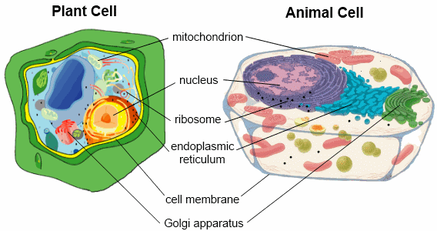

The mitochondria found in both plant and animal cells are the organelles that release the energy from sugar molecules. The cell membrane, or plasma membrane, of a cell allows the cell to take in nutrients (or food molecules) while keeping out things that the cell does not need. Plant cells that contain chloroplasts can also make their own food by using energy from the Sun. If the plant does not have an immediate need for all the food it makes, it can use storage organs, such as tubers, to store the food for later use.
Plant cells have chloroplasts, a cell wall, and a large central vacuole that are not found in animal cells.

Cellular Respiration

Digestion breaks down many foods, such as starches, into sugars. Cells use a chemical reaction called oxidation to break down the sugars even more. Oxidation is the combination of oxygen with other molecules. This process releases the energy stored in the sugar and makes it useful. This process is called cellular respiration. Both plants and animals use the process of cellular respiration to release energy from sugars. Other products of cellular respiration include carbon dioxide gas and water.

Microbes

A microbe is a very small organism that cannot be seen without the aid of a microscope.
Types of microbes include viruses, bacteria, parasites, protozoa, and small fungi. Microbes can be found living as self sufficient life forms, living in a symbiotic partnership with other organisms in which they both contribute to each other’s survival, or living as parasites that grow, feed, and live on or in another organism to whose survival they contribute nothing. Microbes can serve an important role in the degradation and decomposition of organic materials. They can also cause disease, acting as contagions spread through contact, or as noncontagious infectious agents. Diseases caused by viruses include influenza and the common cold. Bacterial infections include tetanus and anthrax. The different categories of microbial diseases require different treatments. For example, while antibiotics can be effective in the treatment of a bacterial infection, they will not treat a viral infection like the flu.

Microbe | Shapes | Structure | Living cells? | Examples of diseases caused by this microbe | Treatments for infections by this microbe
Virus | Helical, Polyhedral, multi-sided | Simple structure containing DNA or RNA—carried in a shell called the viral coat; no cytoplasm or organelles | Has living and nonliving features | Influenza (flu), common cold | vaccines
Bacterium | Spheres, rods, spirals | Single celled structure, but no nuclei (prokaryotic) | Yes | Tetanus, Anthrax | antibiotics, antibacterial, bacterial vaccines, antimicrobials
Protozoan | Ciliates, amoebae, flagellates | Single celled structure with organelles and nuclei (eukaryotic); some protozoa have specialized structures for movement | Yes | Malaria, Toxoplasmosis | antimicrobials, antibiotics
Fungus | Numerous, cells called hyphae | Multicellular structure with a cell wall and organelles, including a nucleus (eukaryotic), but no chloroplasts | Yes | Athlete’s foot, Ringworm, Aspergillus | antifungal, antimicrobials

Protists
Protists are microscopic organisms containing a nucleus or nuclei that hold their genetic material,
and accordingly are categorized as eukaryotic.
Most protists are one-celled organisms that exist as single, self-supporting cells. Protists may display either plant-like characteristics, animal-like characteristics, or a combination of both. For example, some protists have chlorophyll and make their own food through photosynthesis like plants, while other protists are more animal-like and must consume their food. Protists can be categorized based on the way in which they move around. Protists may travel using a long, single flagellum, false-foot-like pseudopodia, or many hair-like cilia.

Organism | Structure | Obtains food | Movement | Picture
Euglena | single, self-supporting cell | photosynthetic and consumer | whip-like structures called flagella | 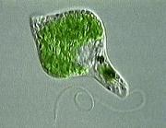
Amoeba | single, self-supporting cell | consumer: surrounds, engulfs, and ingests its food with pseudopodia | "false feet" called pseudopodia | 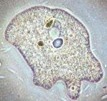
Paramecium | single, self-supporting cell | consumer: draws food into a mouth-like opening lined with cilia | numerous short, hair-like cilia | 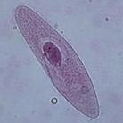
Volvox | spherical colonies | photosynthetic: uses green chloroplasts to trap sunlight for use in producing energy | numerous short, hair-like cilia | 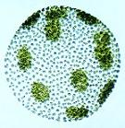

Spread of Microbial Diseases
There are many different types of diseases that could strike in any given population and wreak havoc on overall health. It is important for a community to know the normal disease rates so that an epidemic can be recognized. Rapid realization that an epidemic is occurring can help the community to respond quickly and effectively. It is also important to know which diseases are most likely to break out. This can help members of the community to plan possible treatments and quarantine practices for the most likely situations. Knowing how different diseases spread and how to treat different diseases may also be important for quickly handling an outbreak once it occurs.

Epidemics

An epidemic is an outbreak of a disease that affects an unusually large number of individuals within a population, community, or region compared to recent memory. It does not affect individuals worldwide.

Pandemic

A pandemic is an epidemic of infectious disease that has spread over an entire continent, multiple continents, or even worldwide. A secondary difference is that an epidemic disease is not necessarily contagious (for example, obesity), while a pandemic disease is always contagious.

Disease Vectors

A disease vector is any organism that can spread infectious disease to another organism through bites, scratches, body fluids, or other contact. Rats, ticks, and mosquitoes are examples of vectors. Sometimes, a vector is not harmed or killed by the disease it carries. These vectors are especially dangerous because they are able to spread the disease to many other organisms. For example, the western blacklegged tick is a vector that carries Lyme disease. However, the bacterium that causes Lyme does not harm the tick that carries it.

Disease Prevention

Washing hands, sterilizing equipment, and using disinfectants to clean homes, have reduced the spread of many diseases and led to safer medical practices. Better sanitation and safer processing of food and water have improved the length and quality of human lives. Medicines, such as antibiotics, have been developed to fight bacterial infections like strep throat. Vaccinations using weak or inactive strains of viruses strengthen the body's immune system against many serious infections, like measles.

Genetics & Biotechnology

Biotechnology applies biological scientific knowledge to create products and processes for human use.
The Human Genome Project was a thirteen year long research effort that included scientists from several countries around the world. The main goal of the Human Genome Project was to sequence all the base pairs that compose human DNA.
While working on this project, scientists discovered that there are approximately 20,000 to 25,000 genes in the human genome. When scientists completed the Human Genome Project in 2003, the scientists produced a gene map which showed the relative location of each known gene on every human chromosome.

Genetic Modification

Applications of the Human Genome Project involve genetic engineering. Genetic engineering, or genetic modification, is the process of manipulating genes for practical purposes. Using this technology, different enzymes can be used to cut, copy, and move segments of DNA.

Cloning

Identical copies of genes and organisms may be produced through cloning. Gene cloning is the process through which a segment of DNA is copied. Gene cloning is commonly performed in science research labs, so scientists can produce enough material to study. Reproductive cloning is the process through which an identical copy of an organism is produced from an adult body (somatic) cell. Reproductive cloning is difficult to perform. In fact, more than 90% of clones do not develop into adult organisms, and the organisms that do develop often have poor health and die early. Clones of a number of animals, including sheep, mice, monkeys, and pigs, have been created. To date, however, human clones have not been created, and in most places, it is considered unethical to even attempt to create a human clone.

Earth’s History

The age of Earth is calculated to be approximately 4.6 billion years old. Scientists can learn about
the history of the Earth by studying rocks and fossils.

Uniformitarianism

The Earth has evolved, or changed, over time. Uniformitarianism is a geological principle stating that processes shaping the Earth today operate the same way and at the same rates as they did in the past. Another way to state uniformitarianism is that the present is the key to the past. For example, geologists assume that volcanoes erupted in Earth's ancient past much the same way they do today.

Geologic Time Scale

Scientists learn about Earth's history by studying the rock and fossil record. Based on this record, scientists have learned how Earth and its atmosphere have changed over time, and they have divided Earth's history into distinct intervals of time on the geologic time scale. The geologic time scale begins with the formation of the Earth around 4.54 billion years ago. The geologic time scale is divided into segments: eons, eras, periods and epochs.
A common way to organize geologic time is to break it down into four main intervals. The first interval is Precambrian time, which accounts for all of Earth's history before the Paleozoic era. After Precambrian time, Earth's history is divided into three eras, beginning with the Paleozoic era, then the Mesozoic era, and finally the Cenozoic era.

Ice Core Data

Ice core data is gathered by climate scientists to compare the composition of the atmosphere today to its composition in the past. When snow or ice falls on certain regions on Earth, such as on Greenland, much of it does not melt. It is instead preserved for many thousands of years in layers of ice, with each layer representing one year. Such snow contains information about the atmosphere that it formed in. For example, from the ice cores, scientists can learn the concentrations of different gases in the atmosphere at different times in Earth's history.

The Rock Cycle
There are three major classifications of rock, based on the method of their formation: igneous rock, metamorphic rock
and sedimentary rock. The rock cycle is the series of processes by which rocks are transformed from
one type to another and continually renewed.
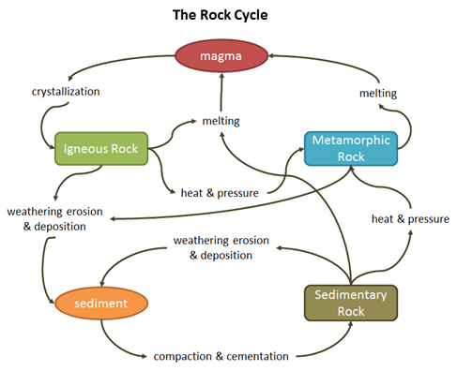
The rock cycle is a model that describes how rocks are created, changed, and destroyed. There are three major types of rock: igneous rock, metamorphic rock, and sedimentary rock. During the rock cycle, each type of rock may be changed into another type.
The rock cycle also includes several different processes. Crystallization is the process by which magma cools and forms solid rock. Heat and pressure often change one type of rock into another. Weathering, erosion, and deposition are the processes that break rock down into sediment at the Earth's surface. Wind, rain, running water, and ice commonly take part is these processes. Compaction and cementationis the process of loose sediments being formed into sedimentary rocks. And melting, of course, is the process that transforms solid rock back into liquid magma.

Plate Tectonics
The theory of plate tectonics says that the Earth's outer layer is divided into a dozen or more brittle, rocky plates.
These plates are always in motion because they are floating on the Earth's flowing upper mantle. When the plates move,
the continents and ocean floor above them move as well.
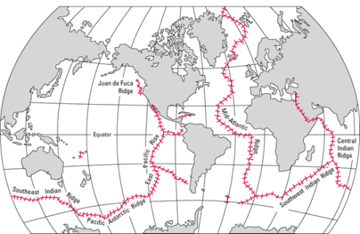
Scientific evidence suggests that all seven of the continents on Earth today used to be connected in a single land mass called Pangaea. Plate motion caused Pangaea to break up and the individual continents to change shape and move away from their placements within Pangaea. The map below shows the approximate locations of the continents on Earth's surface 250 million years ago. Evidence for the existence of Pangaea includes the following facts: 1. Fossils of similar life forms have been found on different continents. 2. Climate evidence include fossils of ice scratches in Africa, and evidence of tropical plants in Greenland 3. Some of the different continents that exist today have similar types of rocks.
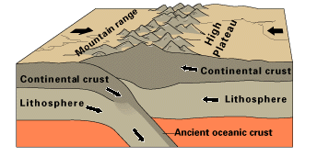
The scientific theory that explains the movements of the continents is called plate tectonics. The word "plate" is used to describe large, brittle blocks of the Earth's surface which appear to move upon the Earth's mantle as large pieces. At the places where two plates meet, constructive (building) or destructive (tearing down) processes may take place. Some of those processes are discussed below.

Convergent Boundaries (plates move together)

Plates move very slowly, at a rate of one or two centimeters per year. Over hundreds of millions of years, plates sometimes collide. When continents meet head-on, the crust tends to buckle and be pushed upward or sideways. This process, sometimes called "mountain building," is how some mountain ranges are formed. Some mountain ranges were formed so long ago that they have become eroded down to low hills. Other mountain ranges, such as the Himalayas and the Alps, are still slowly growing during the present day.

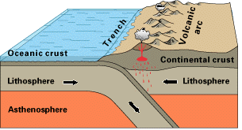
Volcano Formation

In some places, the crust on the ocean floor sinks back into the Earth's mantle. As the crust sinks, it melts, and hot melted rock rises up, squeezing through widening cracks. Magma escapes to the surface and creates volcanoes. A volcano is an opening in the Earth's crust from which lava, steam, and/or ashes erupt or flow. When a volcano erupts, the lava flows down and hardens to form new land. This new land may take the form of a volcanic mountain, a plateau, an island, or an archipelago. An archipelago is a chain of islands. Volcanoes are usually found in the ocean or along the coast. Volcanic eruptions can cause rapid destruction of habitats and changes to a landscape. They can also benefit the surrounding area. Volcanic ash and dust are rich with minerals. These minerals seep into the soil, making it more fertile and allowing new vegetation to grow back quickly. Another benefit is that many precious metals and gemstones can be found in cooled lava.
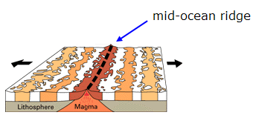

Divergent Boundaries (plates split apart)

Plate tectonics is a relatively new scientific concept, combining the earlier theories

of continental drift and sea-floor spreading. Sea-floor spreading is the movement

of the Earth's crust away from the mid-ocean ridges.
During the process of sea-floor spreading, hot rock rises up from the mantle and spreads out on the surface to form the ocean floor. As the ocean floor spreads, it
pushes the plates around, which in turn move the continents to new locations.
The map below shows the locations of the Earth's mid-ocean ridges, which are
the sites of sea-floor spreading.

Transform Boundaries (plates slide next to each other)
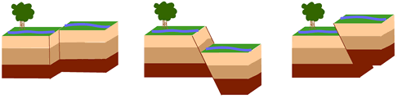
Sometimes, plates do not hit head on, but rub past each other instead. Since they do not have smooth edges, the rubbing is jerky and uneven. Pressure builds up and is then suddenly released. The result is an earthquake. An earthquake is the sudden moving and shaking of a part of the Earth's crust. Earthquakes occur along fault lines, which are cracks in the Earth's crust where lithospheric plates move past one another due to tectonic forces. There are different types of faults, and rocks may move along each of these in a different way. Examples of some different types of faults are shown in the pictures below.
Earthquakes can change the surface of the Earth very quickly as rocks on both sides of a fault line suddenly move.

Geologic Dating
The age of Earth is calculated to be approximately 4.6 billion years old. Scientists can
learn about the history of the Earth by studying rocks and fossils.
Rocks provide clues about what was happening on Earth when they formed. Geologists study rocks in order to figure out the Earth's history. A very important part of this process is figuring out the age of different rocks. This enables geologists to determine the order of events in Earth's history and how the Earth has changed over time. There are two broad types of geologic dating—relative dating and absolute dating.

Relative dating is a method in which the age of an object or event is determined relative to some other object or event. For example, a geologist may determine that one rock layer is older than another rock layer based on their positions in a sequence of rock layers. Three of the main principles of relative dating are discussed in the bulleted list below.
- The principle of superposition states that younger rock layers form on top of older rock layers. This principle allows geologists to determine that layers at the bottom of a rock-layer sequence are older than those at the top. This principle works in most cases, although it does not apply to rock layers that have been turned upside down by tectonic forces or other processes.
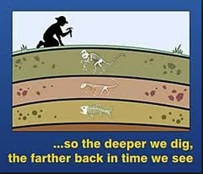
- The principle of original horizontality states that sediment is deposited in horizontal layers. Sedimentary rocks form as horizontal rock layers from this sediment. This principle allows geologists to recognize when rock layers have been moved from their original positions. For example, when a geologist finds rock layers that slant at an angle, he or she knows that the layers have been tilted from their original, horizontal position. Further, the geologist knows that the tilting event must have happened after the rocks formed. Thus, they know the age of the tilting event relative to the age of rock formation.

- The principle of cross-cutting relationships states that a geologic feature is younger than the features it cuts across. For example, a fault that cuts across rock layers is younger than the rock layers. The idea here is that the rock layers had to exist before the fault could cut across them. Another common example of cross-cutting is an igneous intrusion that cuts across other rocks. For example, a body of magma can force its way up through the Earth's crust, cutting across existing rock layers and cooling to form an igneous rock. This intrusive rock is younger than the rock layers it cuts across.
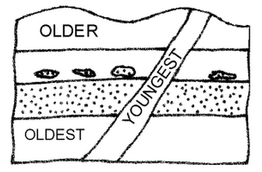

Absolute dating is a method in which the age of an object or event is estimated as an actual number of years. For example, a geologist might determine that a layer of volcanic ash is 20 million years old.

Radioactive dating is a method in which the age of a rock, mineral, or fossil is calculated based on the amounts of certain radioactive substances in the sample compared to other substances in the sample. The proportion of an unstable, radioactive element in a mineral or fossil changes over time as the element decays. In the process of radioactive dating, scientists measure the amount of the radioactive element that is present and compare this to the rate at which the element decays. Together, these two pieces of information can allow scientists to determine when a rock or fossil formed. There are several different kinds of radioactive dating including radiocarbon dating. Radiocarbon dating is a type of radioactive dating that uses different types of carbon to measure the age of fossils or other materials. Radiocarbon dating relies on the fact that carbon-14 is radioactive and decays at a predictable rate. Since the initial amount of carbon-14 compared to carbon-12 in many samples is known, a scientist only needs to measure the amounts of carbon-14 and carbon-12 currently in a sample to calculate its age.

Fossils
Fossils are traces of past organisms preserved in the Earth's crust. They may include actual remnants of structures or just imprints of structures. Scientists study fossils to learn about the history of the Earth's surface, climate, and life forms.

Fossil Formation

Fossils are most commonly found in sedimentary rock, which forms as layers of material settle upon each other, press together, and harden over time. As time passes, new layers form upon the older layers. This means that as time passes, fossils are buried deeper and deeper in the Earth. Therefore, fossils found in lower layers of sedimentary rock are older than fossils found in upper layers of sedimentary rock. The clues found in fossil layers provide valuable information about how Earth's organisms and the Earth itself have changed over time. Fossils can also provide information about how the Earth's surface has changed over time. If fossils of marine organisms are found in areas that are now dry land, scientists may assume that the area was once under water. This gives scientists important clues about land elevation, landforms, and sea level at various times in Earth's history. Fossils also show how the continents of the Earth have moved over time. Fossils that have been found in both Australia and in Asia show that these continents were connected in the past.

Fossils & Organisms

Fossils are remnants or traces of organisms that are preserved in layers of rock. If an organism gets buried under sediment, the soft parts will decay, while the hard parts (bones, teeth, etc.) undergo a chemical change to become preserved in the sediment, which later becomes rock. Some types of organisms that lived in the past are no longer alive on the Earth today. These organisms are said to be extinct. Fossils can show whether or not extinct organisms were similar to those that are living today. Fossils provide a variety of information that scientists can use to learn about the organisms that once lived on Earth. Index fossils are fossils of organisms that were only found during very specific times in history. If a new fossil is found near an index fossil, it can be assumed that it is from approximately the same time period. Index fossils can also be used to date strata layers. Index fossils can help scientists decide what the climate was like during that time period. Trilobites are an example of index fossils.

Adaptations

Plants and animals have special characteristics, or adaptations, that help them survive in the environment that they live in.

An adaptation could be a part of an organism's body or it could be a change in the organism's behavior.
Adaptations are traits that increase the chance that a plant or animal will survive in a specific environment. Adaptations might help an organism find food or shelter, survive certain weather conditions, or protect themselves. Some adaptations are traits that cause a behavioral or physical change as the seasons change. For example, some birds migrate to avoid the cold weather of winter.

Getting Food or Energy

Without food, animals cannot survive, so animals have adapted certain features that allow them to more easily obtain food. For example, the great white shark has a strong sense of smell that allows it to locate food, and it has sharp teeth that allow it to attack its prey. Lizards have long, fast-moving tongues that allow them to catch insects. Giraffes have long necks that allow them to reach high into trees to get leaves for food. Animals may also have adaptations that help them respond to changes in the availability of food. For example, some types of squirrels store nuts for winter, while bats, hedgehogs, and some other animals hibernate in winter to survive the long period where there is little food available.

Finding Shelter

Some animals have adaptations that assist them in finding or creating shelter. For example, woodpeckers make nests in the hollows of trees. These birds have adapted to have sharp beaks that make it possible for them to tunnel through the hard bark of trees and create hollows to live in.

Surviving the Weather

Adaptations can help plants and animals survive certain weather conditions. For example, many plants grow during summer months and then stop growing during winter months to conserve energy. Animals can have adaptations that help them survive the weather conditions in their environment as well. For example, emperor penguins have adapted to have a thick layer of blubber that helps keep them warm in cold areas. Polar bears have thick fur and padded paws to help them survive the extreme weather of the Arctic. Flying birds, such as the tundra swan, migrate to survive cold winters and find food more easily during stressful environmental conditions.

Protection

Adaptations can also help plants and animals protect themselves. One method of protection is camouflage, which is where the animal's appearance helps it blend into its environment. Many stick insects, lizards, and frogs have adapted a form of camouflage that makes it hard for predators to see them.

Diversity, Adaptations, Evolution & Extinction
Variations exist in every population. When variations help an organism survive, more organisms with those variations are likely to be produced. This causes the characteristics of a species to evolve over time. When variations hinder an organism's ability
to survive, fewer organisms with those variations are likely to be produced, which may lead to extinction.

The Diversity of Life

Different environments and conditions have caused organisms to slowly change and adapt over time. Changes and adaptations increase the diversity among living things because they increase the number of different types of organisms that exist. Variations and diversity can also occur among organisms within the same population, or organisms of the same species that live in the same place at the same time. The diversity found within and between species is both the cause and result of natural selection.

Natural Selection

Natural selection is the tendency for more favorable traits to be selected by nature over less favorable traits. For example, imagine a population of rabbits living in a very cold environment. By chance, some rabbits have thicker fur than other rabbits. The rabbits with the thicker fur are more likely to thrive, reproduce, and pass on the trait for thicker fur to their offspring. The rabbits without the thicker fur are less likely to survive the cold environment, so these rabbits will not reproduce and pass on their traits. Thus, over time, the presence of the favorable trait increases within the rabbit population, and the presence of the unfavorable trait decreases within the rabbit population. The favorable trait is naturally selected over the unfavorable trait. It is important to note, however, that natural selection can only occur if there is variation within a population. If all of the organisms within a population are identical, then all of the individuals would possess the same traits, and it would not be possible for some traits to be more favorable than others.

Evolution

Evolution is the cumulative change in the characteristics of a population over time. The driving force of evolution is natural selection. As a result of natural selection, organisms with more favorable traits are more likely to survive, reproduce, and pass on the favorable traits to their offspring. As these traits are passed on from generation to generation, the characteristics of a population evolve, so the majority of individuals within a population possess the favorable traits.

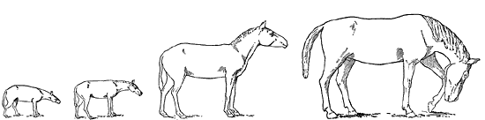
For example, the image shows four of the many stages in horse evolution. The image to the far left shows how horses looked approximately 47 million years ago. These horses were much smaller than the modern horse, they had toes instead of hooves, and they had smaller, weaker teeth. Over time, the horse evolved and developed hooves to better handle rougher terrain, longer legs to better run from predators, and stronger teeth to grind tougher grass.
The image to the far right shows how horses look today. These changes, or adaptations, occurred over millions of years and many generations, thus showing how small differences between parents and offspring can accumulate over time, so future generations can be very different from their ancestors. Fossil evidence is typically used to show the evolution of species over time.

Extinction

The fossil record can also show if a species ceased to exist, or became extinct. If no modern-day species resembles fossils that have been discovered, scientists can conclude that the species became extinct at some point in time. Extinction is a common event that occurs in Earth's history, and it can be caused by a number of factors, including sudden changes in the environment, disease, over hunting, and catastrophes. Most of the species that have ever existed are now extinct. Genetic variation is an important factor in preventing extinction. For example, imagine a population of deer that is infected by a disease. If at least some deer have a genetic variation that allows them to be resistant to the disease, then those deer could survive the illness, reproduce, and allow the species to continue to exist. A failure to adapt is also a cause of extinction. For example, if a population of squirrels prefers to eat nuts, but all of the nuts are removed from their environment, the squirrels would have to move to a different environment, adapt to be able to eat another type of food, or face extinction.

Evolution - Evidence of Change

Species change over time. The process through which these changes occur is known as biological evolution. Various forms of scientific evidence, including fossil records and biochemical, anatomical, embryological, and physiological similarities, allow scientists to classify organisms in order to show probable evolutionary relationships and common ancestry.

Fossil Evidence

A great deal of Earth's history can be determined using fossils. Fossils are remnants or traces of organisms that are preserved in layers of rock. If an organism gets buried under sediment, the soft parts decay, while the hard parts (bones, teeth, etc.) undergo a change to become preserved in the sediment. This sediment eventually hardens to becomes rock. Fossil records provide evidence for evolution, or changes in species over time. By studying the fossil record of a given species, it is possible to see the many changes that have taken place over multiple generations. These changes are called adaptations. Fossils can also show that organisms that are alive today evolved from earlier species. Or they can be used to show that two different species have common ancestry.

Comparative Anatomy

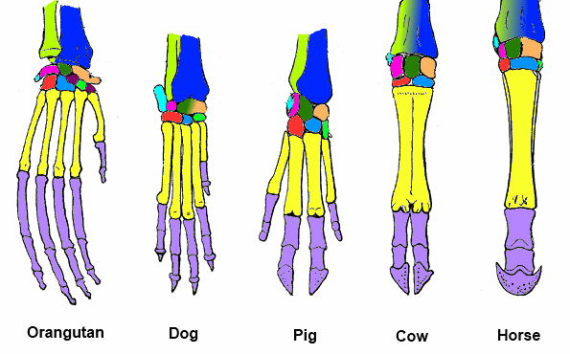
Much can be learned by comparing the structural similarities and differences of living things. Homologous structures are structures found on one species that have the same basic structure and embryonic origin as those found on another species. If homologous structures are found on two different organisms, the species are related, even if only distantly. Organisms with homologous structures share a common ancestor, but at some point, mutations contributed to the rise of the new species. The forelimbs of five mammals are presented to the right. Homologous structures have the same basic structure and share an ancestor, but may have different functions

Analogous structures have the same function, but do not share a common origin. Analogous structures evolve separately in unrelated species, and their presence does not imply that the organisms descended from the same ancestor. Because analogous structures evolved separately, their structure and arrangement are also very different.
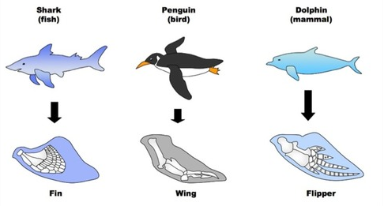

Vestigial structures are non-functional remnants of features that were once operational in a distant ancestor. These structures help establish evolutionary pathways for modern organisms. There are a number of vestigial structures found
in humans. The following list provides some of the major examples:
- coccyx (tailbone) - attachment site for muscles that control tail movement
- appendix - an organ that helped with digestion of plant material, useful for hunter-gatherer ancestors
- wisdom teeth - remnants of a once larger jaw or replacements for lost teeth

Habitats & Basic Needs of Organisms

All living organisms have a set of needs that must be met in order for the organisms to live and grow.

These are called basic needs. Organisms get their basic needs met in their habitats.

Habitats

The place where a plant or animal lives is called its habitat. A living organism's natural habitat gives it what it needs to survive. Organisms depend on both living and nonliving parts of their habitats to meet their basic needs. Organisms interact with, and can be dependent upon, one another. The habitat in which a species of plant or animal lives will determine the adaptations that it will develop, over many generations, in order to survive there. Habitats can change or even disappear. If change is drastic or if the habitat disappears suddenly, such as when all the trees in an area of forest are cut down, the organisms may not be able to get their basic needs met, and they may move to another habitat or die off.

Basic Needs of Animals

Food provides energy for animals. Animals get food by eating other living organisms. Some animals eat plants, while some animals eat other animals.

Water is a basic need for all animals, and it is a nonliving part of an ecosystem. Some animals, like fish, live in water all of the time. Many other animals need to drink water every day to survive. A few kinds of animals can get enough water from the food they eat that they do not need to actually drink water.

Oxygen is a gas that can be found in the atmosphere and dissolved in bodies of water. It is important for the survival of all animals. Land animals use lungs to get oxygen; water animals get it directly from the water. Once oxygen is taken in, it enters the blood stream and is used by the cells in the body to release energy from food.

Space is the amount of room an organism needs to live and grow. All animals need space in which they can interact with the environment to meet their basic needs. When animals are in a space that is too small, they compete more strongly for resources. Animals crowded together may also be more likely to pass diseases from one animal to another.

Shelter is important for most animals. It provides a place to escape predators and raise young, and it helps animals maintain a constant body temperature. Types of shelters vary greatly, but have one thing in common: they help an animal meet their basic needs. Some animals, such as badgers, moles, rats, and snakes, live in holes underground, or at ground level. Other animals, such as birds and wild cats, make nests or use the branches of a tree for shelter.

Basic Needs of Plants

Sunlight is a basic need for plants because plants use energy from the Sun to make their own food.

Water is a basic need for plants, just like it is for animals. Water is essential to plants because it helps transport nutrients from the soil to the plant's roots and because plant cells need it in order to release energy from molecules of food.

Nutrients from the soil are necessary for a plant's survival. Different plants depend on different soil types for their needs.

Air is a basic need for plants. During photosynthesis, plants use carbon dioxide from the air to make food molecules, then release oxygen into the air as a waste product. During cellular respiration, plants take in oxygen from the air and release carbon dioxide as a waste product.

Space to grow is another basic need for plants. If space is not available, plants will compete for nutrients, and not all of the plants will survive.

Niches

A niche is, generally, how a species makes a living in its environment. More precisely, a niche is how a species responds to, and affects, the entire range of competitors and resources in its ecosystem. In other words, a niche refers to exactly how a species gets is needs met and how it meets the needs of other organisms in its environment. Factors that make up an organism's niche include where the species lives, what it eats, what eats it, how many of it there are, and what its reproductive patterns are. Generally, only one species can occupy any particular niche in a particular ecosystem. Similar niches (ways of making a living) can sometimes exist in different ecosystems. As a result, different organisms can sometimes play similar ecological roles in different ecosystems.

Biotic & Abiotic Factors

Ecosystems can be characterized by their biotic and abiotic factors. Biotic factors are the living components

of an ecosystem. Abiotic factors are nonliving components of an ecosystem.

Biotic Factors--The biotic factors of an ecosystem are the living components. Plants, animals, and all of the other organisms that live in an ecosystem are biotic factors.

Abiotic Factors--The abiotic factors of an ecosystem are the nonliving components. These include rainfall, temperature, sunlight, water, soil, rocks, and air

Carrying Capacity & Population Dynamics

The growth of a population in an ecosystem is limited by the availability of resources. Populations can only grow

to a certain point before there are not enough resources available for all of the organisms to survive.
Limiting factors are things that limit a population's growth. These factors can be resources that organisms need in order to live and that are present in limited quantities. Or, they can be things that limit the growth of the population in other ways, such as a population's rate of reproduction or the presence of a disease. Limiting factors can be biotic or abiotic. For a plant population, a limiting factor might be the temperature, the availability of light, or it might be the availability of fertile soil. For a hyena population, a limiting factor might be competition for food with other predators, or it might be a low reproductive rate. The number of plants or hyenas in a specific ecosystem will be limited by the resource that is the population's limiting factor. Limiting factors can be created by human activities. If there is a chemical spill that kills plant and animal life in an area, this could limit how successful the surviving populations can be. Humans also destroy large amounts of plant and animal habitats. So space is often a limiting factor for many wild plant and animal populations. All stable populations are subject to at least one limiting factor. The limiting factor of a population determines the population's carrying capacity, or the maximum number of this kind of organism that a specific ecosystem can support over a long period of time. The carrying capacity is limited by the available energy, water, air, space, food, and minerals.

Competition

Since there are limited amounts of resources in an ecosystem, if one organism gets a particular resource, another does not. This leads to competition as two organisms try to access the same resources. Food, water, sunlight, and space are examples of resources that organisms compete for. Plants and animals of the same species may compete for resources such as food, water, shelter, and space. Populations of different species will also compete with one other if their needs are the same as the needs of another population in that ecosystem. For example, trees in a forest compete for sunlight. As one tree grows taller, the shorter trees are shaded by it, and they receive less sunlight. The shorter trees may die as a result.

Organism Interactions

Plants and animals, including humans, interact with and depend upon each other to satisfy their

basic needs. Common organism interactions include cooperation, competition, commensalism,

mutualism, parasitism, predation, and scavenging.

Cooperation & Competition

Organisms have many basic needs, including food and shelter. Sometimes, organisms cooperate with each other to obtain these basic needs. For example, a pack of wolves might cooperate with one another to kill a large bear that they can share as a meal, or a group of humans might work together to build a house that they can share for shelter. At other times, organisms compete with each other to obtain their basic needs. For example, one bird might fly faster than another bird, so it can catch prey before the other bird.

Commensalism

Commensalism is a kind of organism interaction in which one of the organisms benefits while the other is not significantly harmed or helped by the interaction. Often, the benefit that the organism receives is the ability to find food more easily or protection from other organisms. For example, large grazing herbivores, such as cattle and horses, often stir up insects as they graze on grass in fields and pastures. Birds known as cattle egrets often follow behind the grazing herbivores and eat the insects that have been displaced. Since the cattle egret benefits by being able to find food easily and the grazing herbivores are not affected by the presence of the egrets, their interaction is an example of commensalism.

Mutualism

Mutualism is a kind of organism interaction in which both organisms involved receive a benefit. Flowers and their pollinators are one of the most common examples of mutualism because many kinds of plants depend on insects, such as moths, bees, wasps, and beetles, to perform pollination in order to reproduce. Plants that rely on pollinators attract the pollinator by the shape, color, or smell of their flowers. As the pollinator feeds on the nectar or pollen from the flower, some of the pollen sticks to its legs and body. When the pollinator visits a second plant of the same species, the pollen from the first plant is transferred to the reproductive organs of the second plant, and pollination occurs. Both organisms receive a benefit from this interaction. The pollinator receives access to a food source and the plant is able to reproduce because of their relationship. Bees are pollinators that receive nectar or pollen from flowering plants. They also aid in the pollination of the plant, which makes the relationship mutualistic.

Parasitism

Parasitism is a kind of organism interaction in which one organism benefits and the other organism is harmed by the interaction. The organism that receives a benefit is known as a parasite. The organism that is harmed by the relationship is known as the host. The host species is usually impaired slowly over a long period of time. Parasites can live either inside the body of their host or externally. Common external parasites include fleas and mosquitoes which feed on the blood of their hosts. Internal parasites, such as tapeworms, live inside the body of their host and absorb nutrients from the host's body. In both cases, the parasite receives nutrients at the expense of the host and the host can no longer use these nutrients for its own life processes.

Predation

The biological interaction in which one organism (the predator) hunts, kills and eats another organism (the prey) for energy is known as predation. Predators use their prey as a source of food. Predation is different from parasitism because the prey is killed immediately for consumption. During parasitism, the host is kept alive for a long period of time so that the parasite can continue to receive nutrients from the host. An example of predation is a lion hunting, killing, and consuming a zebra.

Energy in Ecosystems
Organisms within an ecosystem are dependent upon the other organisms because energy is passed
from one organism to another as food.

Almost all food energy comes originally from sunlight. Producers absorb the Sun's energy and transform it into chemical energy when they produce sugars through the process of photosynthesis. The sugars are food for the producers. Producers can use the food immediately, or they can store it for later use. When the producers are eaten by consumers, this energy then passes to the consumers. Since producers get their energy from sunlight, and the Sun is constantly radiating this light, the energy in an ecosystem is always being replenished. The chemical energy in sugar molecules can change forms inside organisms. For example, sugars can be broken down in an animal's body to produce thermal energy used to maintain body temperature. Both plants and animals release energy that is stored in molecules of sugar by oxidizing the sugars during the process of cellular respiration.

Producers

Producers are organisms that use the Sun's energy to make their own food. Green plants are producers. They make their own food using energy from the Sun in a process called photosynthesis. Other producers include single-celled organisms such as algae, bacteria, and protists. Producers can also be called autotrophs, which means "self-feeding," because they use energy from sunlight to manufacture their own nutrients. All of the other organisms in an ecosystem depend on producers for energy. This is because humans and other animals cannot make their own food. Some producers get the energy to make food from chemical compounds instead of from the Sun. These producers live in dark places, such as the ocean floor, where a supply of the chemical compounds they need is constantly produced by geologic features, such as hydrothermal vents.

Consumers

Consumers are animals that get energy by eating producers or other consumers. All animals, including humans, are consumers. Since consumers cannot feed themselves, they are considered heterotrophs, or organisms that get their nutrition from others.

Decomposers

Decomposers are organisms that feed on wastes and dead plants and animals. The role that decomposers play in an ecosystem is very important. Decomposers "clean" the environment by returning nutrients contained in the bodies of dead plants and animals back to the soil, water, and air. The nutrients that decomposers release are then used by producers to make food, and all other organisms depend on this food. Decomposers are also important for the water, carbon, nitrogen, and oxygen cycles. Fungi, such as mushrooms, are examples of decomposers. Some kinds of bacteria and insects are also decomposers.

Food Chains & Webs
A food chain shows one possible route for the transfer of matter and energy in an ecosystem. A food web
shows how food chains that involve some of the same organisms may intertwine.

Food Chain Diagrams
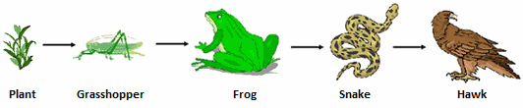
Ecologists use food chain diagrams to trace the flow of energy and matter through ecological communities and discover nutritional relationships. Each organism in a food chain represents a feeding level—sometimes called a trophic level. An example of a food chain diagram is shown below. The arrows in a food chain show the direction of energy flow. The arrows point from the organisms that are being consumed to the organisms that are receiving energy by consuming. For example, in the food chain above, an arrow points from the plant to the grasshopper. This means that the grasshopper is feeding on the plant and getting energy from it.

Classification of Organisms in Food Chains

Sunlight is the primary source of energy in most ecosystems. Producers, such as plants and photosynthetic microorganisms, capture this light energy and convert it to chemical energy stored in sugar molecules that they can then use as food. Producers are at the beginning of all food chains because they are the only organisms that can manufacture their own food from energy that does not come from another organism. In the food chain shown above, the producer is a plant. Organisms that feed on other living organisms are consumers. In a food chain, the second organism is a consumer that eats producers, although it may not necessarily feed on producers exclusively. Organisms that do feed exclusively on producers are called herbivores. Organisms that feed on both producers and other consumers are called omnivores. In the food chain shown above, this level is represented by the grasshopper. The next organisms in a food chain must be consumers that feed on other consumers, although they may feed on producers as well. The frog, snake, and hawk in the food chain above all feed on consumers. The frog is an omnivore, because it also feeds on plant material during at least part of its life cycle. The snake and hawk are carnivores because they eat only other animals. All organisms in the food chain are eventually broken down by decomposers, such as worms, bacteria, and fungi. Decomposers are frequently not shown in food chains, although the wastes and remains of all organisms in an ecosystem are eventually fed on by decomposers.

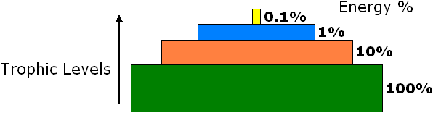
Energy in Food Chains

Producers and consumers both release the energy stored in food molecules which is part of cellular respiration. Some of the released energy is used by the organisms to perform the processes that are necessary for life. The rest of the energy remains in food parts that are excreted as wastes, or it is given off as heat. Because most of the energy in a food chain is used or lost to the environment as it moves up the chain, the bottom level of the food chain contains the most stored energy. In fact, this is where most of the energy in the entire ecosystem can be found. Only about 10% of the energy produced at each level is available to the one above it. For this reason, the higher up in the food chain an organism is, the smaller the size of its population. The diagram below represents the amount of energy available to organisms at four levels in a food chain. Interpreted in terms of the food chain shown above, snakes have access to only 0.1% of the energy present in all the plants in their ecosystem. Because they cannot make use of a larger amount of energy, and therefore there is less energy to sustain each individual snake, there are fewer snakes than plants, grasshoppers, or frogs. The hawks can access even less of the ecosystem's energy, so there are fewer hawks than snakes.

Food Webs

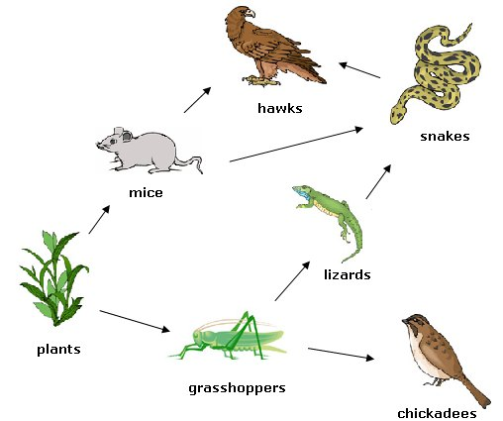
Most animals feed on more than one type of organism, and many plants and animals are fed upon by more than one kind of animal. If several food chains that include some of the same organisms are combined, they make a food web. A food web shows many different food chains for a particular ecosystem and how these food chains interrelate. The food web above includes the food chain discussed earlier. However, it also shows four other food chains:
- plants mice hawks
- plants mice snakes hawks
- plants grasshoppers lizards snakes hawks
- plants grasshoppers chickadees

These food webs intertwine because many organisms eat, or are eaten by, many other types of organisms.

Global Food Webs

All organisms participate in two main interconnected global food webs.
All organisms on Earth, including humans, are part of the two main interconnected global food webs—the aquatic(water) food web and the terrestrial(land) food web. Each organism in these food webs directly or indirectly relies on other organisms in the webs. The aquatic food web includes algae and other microscopic photosynthetic organisms, the animals that feed on them, and finally the animals that feed on those animals. The terrestrial food web includes plants, animals that eat plants, and animals that eat other animals. Much of the interaction between the ocean food web and the land food web takes place in the intertidal zones, or the area of land between high and low tide. Birds are an important link to aquatic and terrestrial ecosystems.

Nitrogen Cycle

The nitrogen cycle describes the movement of nitrogen throughout the atmosphere, lithosphere, and biosphere.
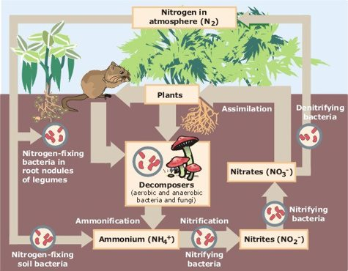
Nitrogen is an essential part of proteins and genetic material. Therefore, all organisms require nitrogen to survive. Even though nitrogen is the most abundant gas in the atmosphere, most organisms are unable to use this form of nitrogen. However, there are a few microscopic organisms and natural processes, such as lightning, that can convert unusable nitrogen in the atmosphere to usable forms of nitrogen in the lithosphere and biosphere.

Steps in the Nitrogen Cycle

During the nitrogen cycle, atmospheric nitrogen (N₂) is fixed, or converted into a usable nitrogen-containing compounds called nitrates, by certain types of microorganisms. Plants can then absorb the nitrogen compounds from the soil and use it to form chlorophyll and other important biological building blocks. Consumers must obtain nitrogen from the organisms they consume. Herbivores receive their nitrogen from the plants that they eat, and carnivores get their nitrogen from the animals they consume. However, all organisms depend on the ability of nitrogen-fixing microorganisms to convert atmospheric nitrogen into a form of nitrogen that plants can assimilate, or take in and use. Finally, nitrogen is returned to the atmosphere through the combustion of fossil fuels or when decomposers break down the nitrogen found in fertilizers, urine, and dead plants and animals.

Carbon Cycle

Carbon and oxygen are necessary for all organisms. These elements move between producers, consumers,

and the atmosphere in a continuous biogeochemical cycle.
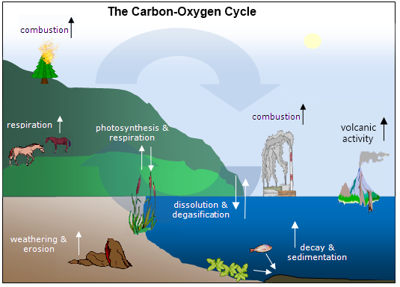
Processes that Release Carbon Dioxide into the Atmosphere
- Cellular respiration is a natural process in which substances are broken down to create energy.
- Decay is a natural process in which organic matter, like dead organisms, decomposes or breaks down.
- Combustion is a reaction in which a substance burns in oxygen.
  - It can be natural, such as a forest fire started by lightning.
  - It can be man-made, such as burning wood and fossil fuels.

Processes that Store Carbon Dioxide
- Photosynthesis is a natural process in which carbon dioxide and water are converted into sugar.
- Sedimentation is a natural process in which pieces of rock and other matter settle out of water and are buried.
- Dissolution is a natural process in which carbon dioxide from the atmosphere dissolves into water.

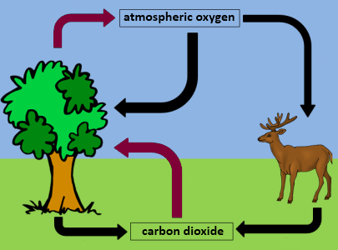
Photosynthesis & Respiration
The two most important natural processes that drive the carbon-oxygen cycle are photosynthesis and cellular respiration. Each of these processes must take place in order for the cycle to function properly. This is because the end products of one process are starting materials for the other. The black arrows represent the flow of oxygen and carbon dioxide due to cellular respiration. The magenta arrows represent the flow of gases due to photosynthesis.
Photosynthesis:
carbon dioxide + water → sugar + oxygen
The end products of photosynthesis are sugar and oxygen. These substances are the starting materials of cellular respiration.
Cellular Respiration:
sugar + oxygen → carbon dioxide + water
The end products of cellular respiration are carbon dioxide and water. These substances are the starting materials of photosynthesis.

The Hydrosphere

The hydrosphere is composed of the Earth's supply of water in all its forms: liquid, frozen, and gaseous.

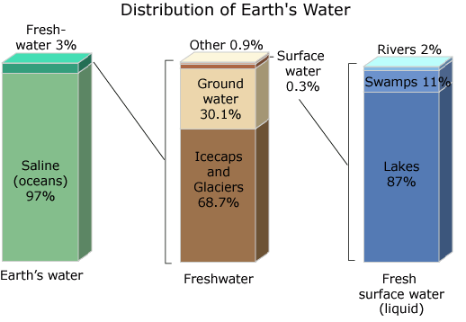
Hydrosphere Components & their Locations

The hydrosphere includes surface water, underground water, frozen water, and water vapor in the atmosphere. Most of the hydrosphere is composed of liquid water and ice. Only a small amount of the hydrosphere is water vapor. The hydrosphere covers about 71% of the Earth's surface. The water in the hydrosphere changes from liquid water to water vapor and moves from one location to another through a process called the water cycle. The water cycle keeps a constant amount of water in the hydrosphere as water changes state (liquid to gas, etc.) and location in the atmosphere. The cycle is mainly driven by solar energy. Most of the water in the hydrosphere is saltwater and is contained in the oceans and seas (97%). The next largest amount of water is found as ice in glaciers and the icecaps (2.4%). Of the freshwater, which is the water that is not in oceans or seas, thirty percent is groundwater. Rivers, lakes, and streams make up less than one percent of freshwater found in the hydrosphere. (see figure below)

The Water Cycle

Water and energy are transferred throughout the hydrosphere, lithosphere, and atmosphere during the water cycle.

The amount of water on Earth remains constant, but it continuously changes forms as energy from the Sun drives the cycle.

Movement of Water During the Water Cycle

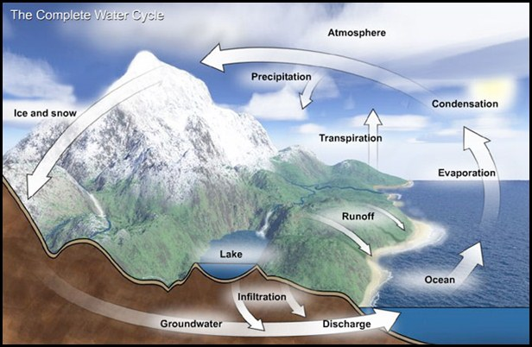
The water cycle describes the continuous movement of water on, above, and below the surface of the Earth. This movement of water in the cycle can have a great influence on weather patterns. There is much more water being stored at any given time than is moving through the cycle. Water may be stored for a short time as water vapor in the atmosphere, for days or weeks in a lake, or for thousands of years in a polar ice cap. However, most of the Earth's water is stored in the oceans.
The water cycle is a cycle with no beginning or end. It includes the following processes:
- Condensation is the changing of gas to a liquid (water vapor to water) and is crucial for the formation of clouds.
- Water returns to the Earth as precipitation. Precipitation is the process by which water vapor in the air condenses to form drops heavy enough to fall to the Earth's surface.
- During infiltration water fills the porous spaces in the rock and soil that makes up the lithosphere. This is one of the main sources of groundwater.
- Surface runoff occurs when no more water can be absorbed into the ground and gravity pulls it downhill until it joins a body of surface water, such as a river, stream, or lake. Some of this surface water may seep downward and become groundwater. The rest of the water in a flowing water body, such as a river, eventually empties into the ocean.
- Evaporation takes place largely from the oceans. It often happens as a result of heat produced by the radiant energy from the Sun–liquid water is heated until it turns to a gas (water vapor) and is released into the atmosphere.
- Transpiration is similar to evaporation in that it is the process by which water is carried through plants, from roots to leaves, where it changes to water vapor and is released to the atmosphere.

Watershed Systems

A watershed is a region of land where rain or snow (along with sediments and dissolved materials) drains downhill

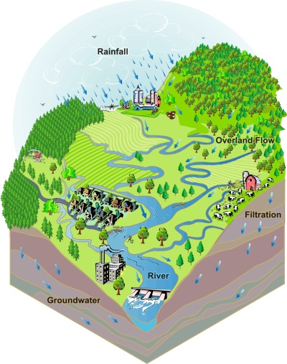
into a particular body of water, such as a river, lake, sea, ocean, or wetland.

Watershed Structure

The area of land where water is drained downhill into a body of water is known as a river basin, or watershed. When precipitation falls onto land surfaces, it can either soak into the ground or become runoff, which is surface water that travels downhill and drains into streams and rivers. The components of a watershed include lakes, streams, rivers, wetlands, and groundwater. Water can flow among all of the components of a watershed, including between groundwater and surface features, such as lakes.Eventually, all rivers, and therefore all watersheds, drain into the ocean.

Use & Importance of Water

Earth is a unique planet because of the presence of water. Water is essential to support life on Earth.

Plants, animals and humans all rely on water for survival.

Locations & Characteristics of Water

Water exists on Earth in many different places and forms. Liquid water can be found underground in aquifers. Liquid, solid, and gaseous water can be found in the atmosphere, and liquid and solid water can be found on Earth's surface. Water found in oceans and seas is salt water. This water is rich in dissolved nutrients and salts. It is too concentrated in these materials for humans to use for drinking. Water found in streams, rivers, ponds, and most lakes is fresh water. Fresh water contains minerals but does not have high levels of dissolved salt. Once it has been purified, is suitable for human consumption. The most common sources of drinking water are aquifers and lakes. However, not all cities are located close enough to one of these for it to be a practical drinking water source. To solve this problem, some cities build reservoirs, or artificial lakes, often by damming a river as shown in the photo. Much of the drinking water for North Carolina's cities comes from reservoirs and groundwater. Drinking water for more rural communities comes from wells.

Water Usage

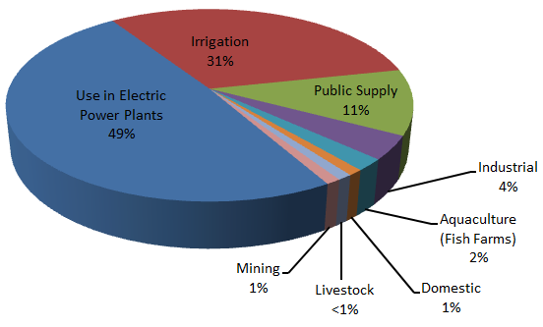
Humans need to drink water in order to survive. But in addition to consuming water for life processes, humans use water in many other ways. Power plants account for almost half of the water usage in the United States. Coal-burning and nuclear power plants require water to generate power. Both types of power plants capture rising steam to create electricity. The second largest use of water in the United States is agriculture. The use of water for crops, or irrigation, requires trillions of gallons of water each year. The amount of fresh water that communities have available determines how they use their water. For example, a city near a river may choose to build a dam and use the river to generate electricity with a hydroelectric power plant. They can also choose to allow industries to build factories on the river and use water from the river for cooling or waste disposal. Communities that have lakes and rivers nearby may use them for recreation, allowing citizens to swim, ski, boat, and fish in the water. Where water supplies are plentiful, lawns and landscapes may be watered regularly. However, in places where water supplies are finite, people must landscape with native, drought-tolerant plants that do not need to be watered with an irrigation system. Water Usage in the United States (2005)

The Ocean

The ocean is the dominant physical feature of our planet.
There is one ocean with many ocean basins, such as the North Pacific, South Pacific, North Atlantic, South Atlantic, Indian, and Arctic. The ocean covers about 70% of the Earth or about 225 million square kilometers. The ocean can be divided up into three main regions: the shore, the open ocean, which is the surface layer at the top of the ocean, and the deep ocean, which is the area located toward the ocean's floor in deeper waters. A fourth distinctly different, but related, region is the estuary. An estuary is an area where fresh water and salty ocean waters mix together. These areas may include bays, mouths of rivers, salt marshes, and lagoons.

Intertidal zone

The shore, or the intertidal zone, is the area of the ocean where the water meets the land. This area is exposed to the air during low tide and is covered in water during high tide. This part of the ocean receives high exposure to sunlight. This area includes only the part of the ocean floor that lies between tide markers and is alternately submerged and exposed based on the ebb and flow of the tide.

Neretic - Area from the low tide mark to the edge of the continental shelf. Includes the coral reefs and the kelp forests. (site of upwelling); Very cold water, limited sunlight, high pressure
Oceanic Zone – The area after the continental shell; Very cold water, limited sunlight, high pressure

Estuary

An estuary is an area in which fresh water and salty ocean water mix together at salt marshes, mouths of rivers, bays or lagoons. These brackish (salt mixed with fresh) water ecosystems are affected by tides. Each high tide brings a new supply of nutrients and small organisms. Marsh grasses take up these nutrients and thrive in the environment. The dense clumps of plants and their roots create shelter for marine life, birds, and other wildlife. Often, sea animals go to estuaries to breed and produce their young. The young sea animals live within the relative safety of the estuaries during the first parts of their lives, until they are strong enough to survive in the open ocean. Estuaries perform functions that help to promote the health of the environment and human populations. They help protect the environment by filtering sediment and pollutants from river and ocean water. They also produce more plant and animal life than many other types of ecosystems on Earth. Many of the animal species that are fished as human food sources spend at least part of their lives in estuaries.

The Ocean as a Reservoir

Earth's ocean is a reservoir of life forms, minerals, nutrients, and dissolved gases.

Biological Diversity

Earth's ocean is a major reservoir of life forms. About 80% of all of the life forms on Earth live in the ocean or on its floor. Coral reefs, found in shallow ocean waters, are some of the most biologically rich ecosystems in the world, containing thousands of different species of fish, coral, and sponges.

Minerals

The ocean is a major reservoir of salts and minerals. It contains a large amount of sodium chloride (3.5%), resulting in the salty nature of ocean water, which is called salinity. Other minerals found in the ocean include potassium, magnesium, sulfur, and calcium. Most elements found in the ocean were carried there in water after the weathering of rocks. This process, along with emissions from underwater volcanoes and hydrothermal vents, help keep the ocean's salinity levels relatively constant. However, humans extract salt from ocean water for use in cooking and manufacturing. In a process called upwelling, warm surface water is blown out to sea by prevailing winds and cold, nutrient-rich water from the deep ocean rises to the surface to take its place. Many of the organisms living in areas where upwelling takes place feed off of the nutrients brought to the surface by the upwelling.

Microorganisms

Just 100 mL of ocean water contains millions of bacteria and hundreds of thousands of phytoplankton, such as algae. Phytoplankton and many kinds of marine bacteria are photosynthetic producers. These two kinds of producers are at the base of almost every aquatic food web in the world.

Dissolved Gases

The ocean is a major reservoir of gases. The ocean absorbs gases from the atmosphere or gives off gases to the atmosphere to help the concentration of gases to stay in equilibrium. The gases dissolved in the ocean include nitrogen (N), carbon dioxide (CO₂), and oxygen (O₂). Plants and other photosynthetic organisms live primarily near the surface of the ocean because that layer of the ocean receives more sunlight than those deeper in the ocean. As plants grow, they take in carbon dioxide and give off oxygen. Therefore, there is more oxygen near the surface of the water, because the plants living there have more sunlight to use for growth. The photosynthetic organisms in the ocean produce 70% to 80% of the world's oxygen.

Technology for Exploring the Ocean
Sonar
Sonar is a measuring instrument that sends out an acoustic pulse (sound) in water and measures distances in terms of the time for the echo of the pulse to return. Sonar is an acronym that stands for "sound navigation ranging." Sonar is very good for providing underwater explorers with information about the shape or makeup of underwater structures or objects

Submarines /Submersibles Submarines are watercraft capable of navigating to specific depths beneath the surface of the water. They are used in deep oceanic explorations to not only see the ocean floor but also to see the creatures that live at these great depths. Some of these submarines are capable of holding people, but some are entirely robotic. Many of them have robotic arms that can be used for obtaining samples of sea life from the ocean depths.

Water Quality

Water monitoring is a necessary step in ensuring good water quality for all living things in a watershed. Monitoring the water allows scientists and public health officials to make necessary changes to improve water quality.

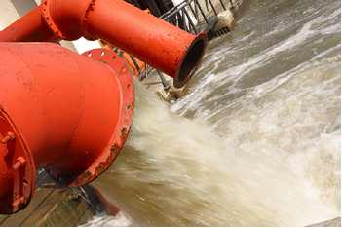
Types of Water Pollution

Point source pollution is that which can be traced back to its origin. It occurs when harmful substances are added directly to a body of water. An example of point source pollution is when pipes delivering wastewater from factories or sewage treatment facilities discharge directly into a lake, stream, or the ocean. Sewage from septic tanks and broken or inadequate sewage systems is a common source of groundwater pollution.
This pipe delivering waste water directly into the river is an example of point source pollution.

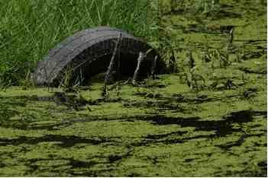
Non-point source pollution can be far more difficult to treat because it cannot be traced back to one source. It is most often the accumulation of runoff containing various substances from different locations. When rain water carries substances such as lawn chemicals, fertilizers, motor oil, or animal waste into storm sewers or rivers, this is non-point source pollution. The heavy growth of algae in this pond could be the result of non-point source pollution, such as runoff containing fertilizer or animal wastes. Stormwater runoff is a serious problem in many urban and suburban areas. The problem is complicated by artificial surfaces, such as buildings, parking lots, and paved roads. These impervious areas not only decrease the groundwater quality by prohibiting natural filtration through the soil, they also increase the risk of flooding and contamination of surface water by allowing leaves and other organic debris to accumulate. Dirt, oil, and debris that collect in parking lots and paved areas can be washed into the storm sewer system and eventually enter local water bodies.

Water Quality Characteristics

Water quality can be affected by biotic and abiotic factors. Water can be tested and characterized with regard to these factors. Testing often includes evaluation of dissolved oxygen, conductivity, clarity, pH, temperature, nutrients, and life forms.
- Dissolved oxygen indicates how much oxygen is available for animals and plants living in the water to use for respiration. A low dissolved oxygen level is a sign of poor water quality, because it can result in reduced animal or plant population size.
- Clarity is a measure that indicates how much light is able to penetrate the water. Light penetration is a requirement for photosynthesis of bottom-dwelling plants. This water quality characteristic is also called turbidity. Water is turbid if it contains high levels of suspended solids, such as fine particles of silt or large amounts of algae or bacteria. Increased turbidity can increase water temperature at the surface and decrease temperature in deeper waters.
- pH is a measure of how acidic or basic the water is. Healthy, natural water systems usually have a pH of between 6.5 and 8.5. Low (acidic) pHs can be damaging to water-dwelling animals and plants. Certain pollutants and acid rain can cause the pH of a body of water to be lowered.
- Water temperature can greatly affect aquatic life. Temperature affects the rate of photosynthesis and the metabolic rates of aquatic organisms. Temperature can further affect aquatic organisms by influencing the amount of dissolved solids and gases the water can hold. High temperature = low oxygen
- Nitrates and phosphates are nutrients that come from both natural and human sources (e.g. fertilizer runoff, septic systems, improperly treated wastewater). Although needed in small amounts in a healthy aquatic environment, too much of either of these nutrients will result in eutrophication.
During eutrophication, excess nutrients in the water cause rapid growth in algae populations. In large quantities, the algae may produce substances that can be toxic to people and animals. In addition, after the large algae population depletes the excess nitrates and phosphates, it quickly dies off. As bacteria in the water work to decompose the dead algae, they use up a large fraction of the oxygen dissolved in the water. As a result, the aquatic plants and animals may not have access to enough oxygen to perform respiration, and they may die.
- BioIndicators, including aquatic insects, crustaceans, and other visible invertebrates can be strong indicators of the presence or absence of certain types of water quality issues. Every species has a certain range of physical and chemical conditions in which it can survive. Some organisms can survive in a wide range of conditions and are more tolerant of pollution. When pollution enters a system, some types of these organisms disappear, while other types become more abundant. Thus, these living "indicators" are referred to as indicator organisms.

Measuring Water Quality

Water quality can be measured using a variety of methods and with many different tools. Research scientists and professionals commonly use a digital water quality instrument that records different characteristics such as dissolved oxygen, salinity, turbidity or clarity, pH, and temperature when placed in the water.

Wetlands and Water Quality

Wetlands are capable of improving water quality and are very important ecosystems in a watershed. Wetlands hold water during floods and slowly release it after flood events. These valued ecosystems restore the groundwater while holding water. Wetlands contain plants that are specialized to grow in water. These plants add oxygen to the water, reduce water temperature through shade, and remove pollutants or extra nutrients from the water.

